New Order Pad System
The new order Pad System has many new features:

General
- Dedicated Program, with MS SQL Database to reduce IT support and make install simpler
- Syncs with Exchequer Accounting Software
- Faster Data Entry and Better User Interface for more efficient Order Taking
- Better reliability as built on MS SQL server for less down time

Supplier
- Find the nearest Supplier, based on postcode area OR distance
- Auto links to Supplier Price List documents
- Supplier pricing held in Database, and imported from Excel template
- Import Supplier prices from spreadsheet, enabling easier setup
- Flag certain Stock Groups as being offered from only certain Authorised Suppliers
- Suggest price based on Margin set on stock code level
- Supplier Actual Price paid set, and available for reporting after Supplier Invoices is entered in Exchequer
- Multiple Supplier contacts + Always BCC e-mail address
- Suppliers which are not relevant to skip hire can be hidden from selection.

Customer Ratings
- Automatically send a mobile friendly e-mail to Customer to capture Supplier rating, and automatically import, day after Collection
- Review customer ratings since x date
- A warning can be set against any Customer/Supplier. This can be used for informing operator of Key account or special terms relating to account.

Orders
- After posting a Purchase Order. Added to a conformation list. The Operator then uses this to double check with supplier that they have processed the order
- Alarms added to chase up Collection and Exchanges
- Notes with attachments
- Button in Exchequer to e-mail SRI Invoice to non-account customer after Credit Card Transaction reconciliation following day
- Identify those which need collection
- Purchase Order has unlimited Special Notes
- Google Maps and Directions available at click of a button
- Sales/Purchase e-mails, containing the Sales Invoice, can have up to 4 attachments for T&C’s
- Repeat Credit Card Transactions if authorised by customer. No need to take credit card details, but on previous card held in Sage Pay.

Searching
We can find jobs, and associated stages, by:
- Customer code if an account customer
- Postcode for Job
- Supplier Account Code
- Any part of first line of address
- Customer Ref
- Job Number, this is prefixed with the operator’s code, and is unique to each job
- OurRef, our invoice number

Marketing
- Capture of customer e-mail addresses for marketing e-mails. For use with Mail Chimp

Reporting
- Suppliers not had price set since x
- User turnover with Actual price paid for services
- Customer reviews since x
- Get captured marketing e-mails since x

Users
When started the system will ask for Username and Password. If user name matches the windows login name, then this will be filled in automatically.
Menu: Admin >> User - gives access to the user list. Each user has a security level.
ID | Name | Description
1 | Developer | Shows all and additional ID’s  All e-mails go to
2 | Boss | All reporting
3 | Admin | All except certain reports.
4 | Reporting User | Additional reporting
5 | User | Standard user

An extra user “Joe Public” is on the user list to book customer reviews against.
This table also gives control over which user can Create and/or edit a Customer/Supplier account

Accounts and Exchequer
All customer and supplier must be created/edited in Order Pad system.
Menu: Records >> Create Customer/Suppliers - gives access to the user list. Each user has a security level.
Menu: Records >> Re-Sync Exchequer Static Data - will resync and changes made in Exchequer

Main Menu
The main window, which resides on the left of the screen, and thus is always accessible, gives access to all functions. It is broken down into:

Work list
The “Work List” tab shows any Orders which are in the process of being taken, but not posted in to the accounts package for processing, with most recent at the top.
Allows access to other users Work List

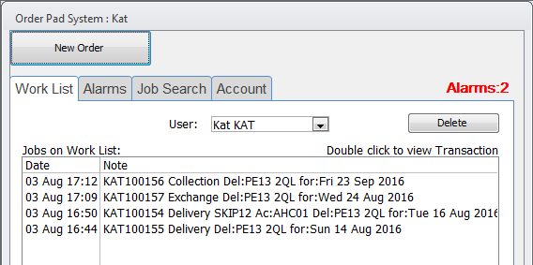
Double Click to open Order Window
Delete any unposted Orders not wanted *
- - This only deletes the item from the list. Use [Options] button on transaction window to delete transaction
This replaces the need for multiple windows in the old order pad system.

Alarms
The “Alarm” tab shows any alarms for today or older.
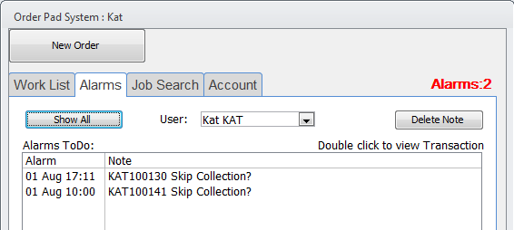
Double Click to open Order
Delete Alarm
Allows access to other users Alarms
Toggle view
Toggle view switches between show alarms to do, and all Notes/Alarms from 2 days ago and the future.

Job Search
The “Job Search” tab allows user to search for a Job.
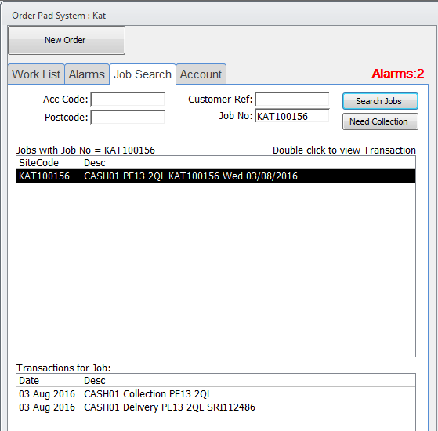
Transactions for Job
Jobs
Search by Accounts code, Customer Ref, Postcode or Job No
Users Orders which require collection but have not been collected. Oldest first. For Current User.

Account
The “Account” tab allows user to access Customer/Supplier records.
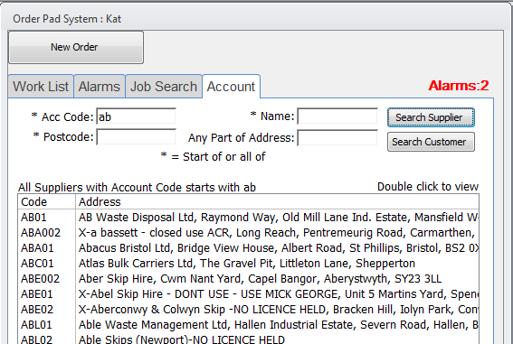
Search for Customer or Supplier
Double Click to open Account Record

See section on “Customers”/” Suppliers” for further explanation

Sync
Available to Admin users. Should be run once a day.
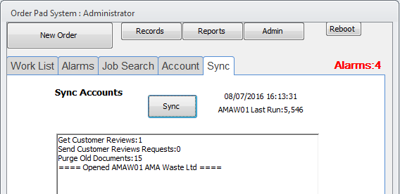
Run Sync
Operation Progress

Daily Operations
Every Day the [Sync] button should be pressed to sync with Exchequer. This will:
- Send customers e-mails asking them to rate the supplier using user outlook account.
- Receive any ratings entered on web site.
- Scan for transactions posted by existing Order Pad during the changeover and import into new Order Pad. These are added to history and can thus be searched for in new system. Also, a link will show to old Order Pad sheet.
  - Scan by Exchequer runNo (set in system settings) for new transactions and add to DB. These include credit notes booked against a job (due to copy reverse). They must have the Invoice reference in Exchequer “Your Ref”, which they normally would have. The sync will then link to credit that specific job.
  - For all SIN and SRI with no THSuppAcCode, go through all the trans find the POR to fill in THSuppAcCode. This will only be applicable to old transactions, from old Order Pad system.
  - For every POR not previously processed (Where THPOROurRefToGetPrice Is not Null), search for POR in Exchequer. If posted, then get the TRUE cost from possible amended POR, and update the TRUE cost on transaction line with values.
  - If systemVar10000 = 1 then populate prices against supplier as best possible. This should be OFF when live.

Customer
Customer are access from the “Account” tab or added using the Menu: Records >> Create Customer/Suppliers.
This will open Customer window:
Customer Details Synced with Exchequer

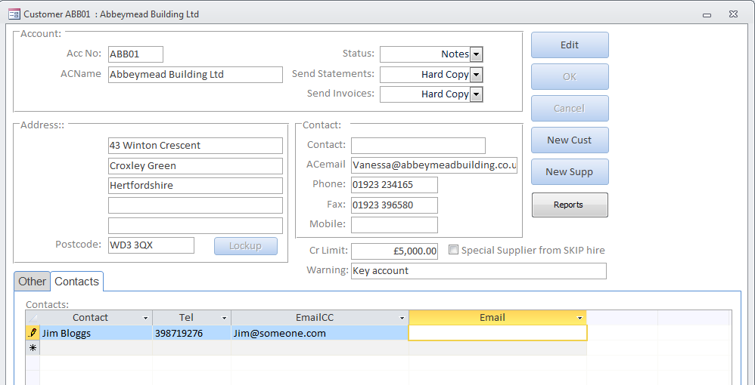
Additional contacts.
Warning displayed on selection and Order Window

Account code is automatically assigned from Account Name.
Creating account, and editing can be restricted to single users.

Suppliers
Suppliers are access from the “Account” tab or added using the Menu: Records >> Create Customer/Suppliers.
This will open Suppliers window:
Supplier Details Synced with Exchequer
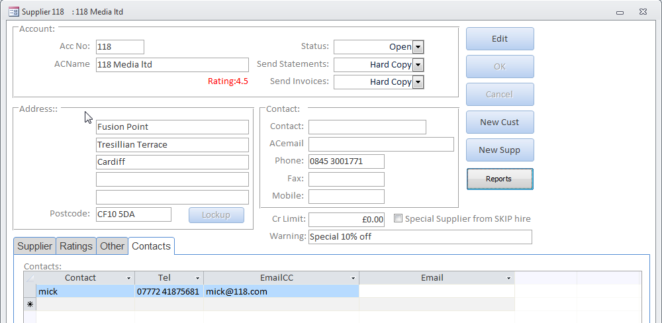
Warning displayed on selection and Order Window
Additional contacts which can be selected/saved from the Order Window
Exclude from Supplier Search
Account code is automatically assigned from Account Name.
The Supplier Tab allows the Supplier prices to be set:
Text to be displayed in pricing against supplier when selecting nearest supplier

Link documents to supplier (Double Click to open)
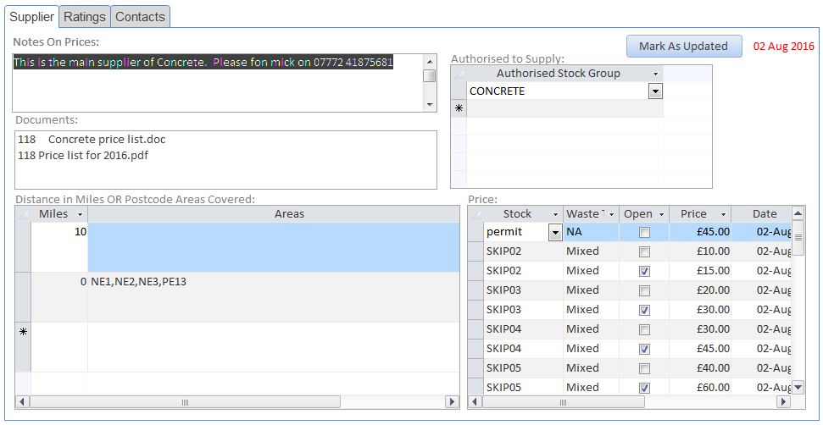
Prices for band

Authorised to supply stock Group
Price Bands can be set for Postcode Areas or Distance in Miles

The above prices are the ones shown in the “Price Import” section.
Prices will be initially populated from previous years’ history.
The [Mark as Updated] button, marks the supplier as having the prices set. A report can be run from the [Reports] button which lists the suppliers which have had not had prices set. Thus helping in the process of setting the new prices in April every year. The red text will show this date after being set.

Documents
The linked documents, lists any documents starting with account code, in designated directory:
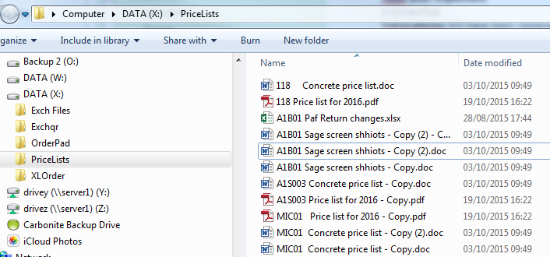
This prices list can easily be associated with supplier.
Also, on the [Reports] button is an option to get all e-mail address for suppliers, to ask for new price lists.

Supplier Authorisation
Curtain stock groups can be marked as requiring authorisation to sell, such as “CONCRETE”. Thus if this group is not entered in the “Authorised Stock Group” list, the user will be warned that the item is not authorised for that supplier. “Supplier is not authorised for suppling CONCRETE”

Orders
New Orders can be started at any time by pressing [New Order] button on the Main window. Any existing order will be saved and added to the “Work List” for future reference.
Orders can be access from the “Work List”, “Alarm”, or “Job Search” tab.

New orders
A new order is assigned as a “Delivery” initially:
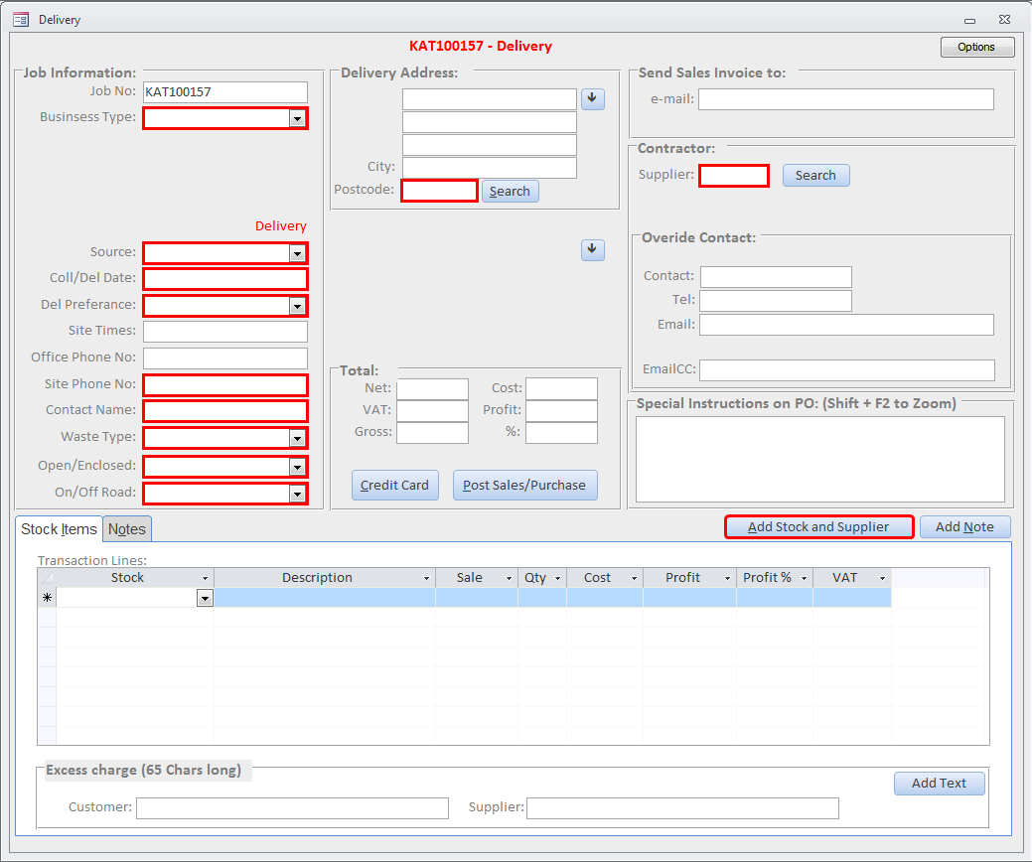
The fields marked as RED are required fields, or require action.

Points of interest

All Selection boxes
All Selection boxes now match text as you type, thus simply entering the first few matching characters of a box selects the items.

Collection date
Instead of entering the date of collection, simply enter the date day number.
Thus:
Becomes:

Contacts
Entering “/” no longer upsets Sage Pay

Address
Move address down one line

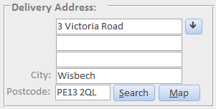
Search by Postcode
Show google map for Delivery Postcode

Supplier and Stock Selection
Although the user can select supplier, and then select stock items on order, a button [Add Stock and Supplier] is provided to select the best nearest supplier for stock item, Waste Type and Open/Enclosed.
Pressing this button will show:
Stock Group

Supplier
Stock Item Required

Distance, A means matched by Postcode Area
Cost from Price Band for Area or Distance
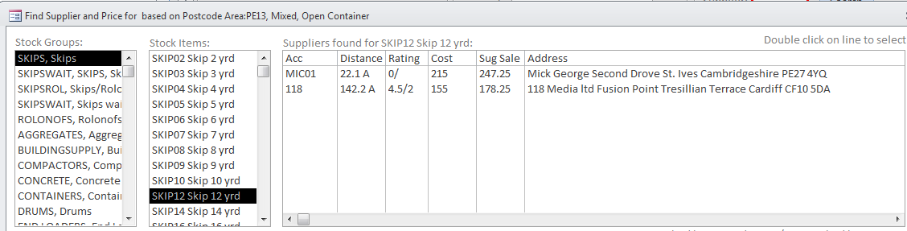
Suggested Price based on Stock Code Margin
Double click to select stock and supplier and add to order

Here we can select the appropriate stock group, stock item to list nearest suppliers.
If “On Road” then a permit can optionally be added, price can be set automatically.

Additional Supplier information
Below this section, addition information is provided for currently selected supplier:
Supplier note

Link documents to supplier (Double Click to open)

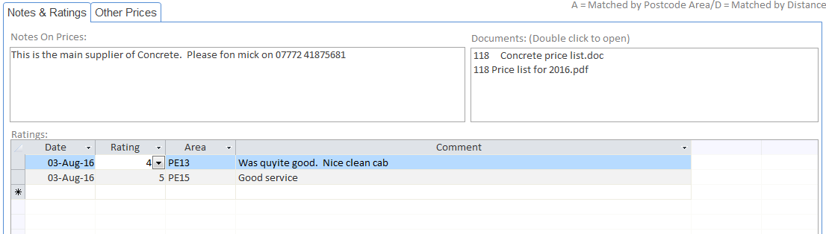
Ratings and Comments from customers

Other Prices
The Other Prices Tab shows any other prices for that supplier:
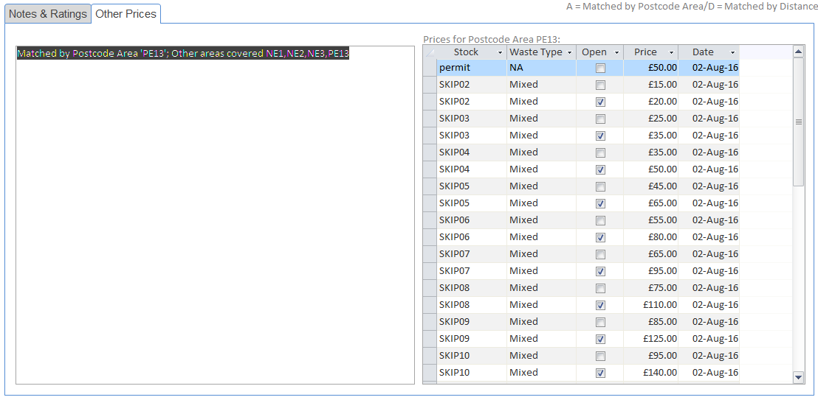
List of stock and prices the Supplier supplies

Thus the user can see other items they may want to add later.

Ordered Stock Items
Having added stock, the items are listed:
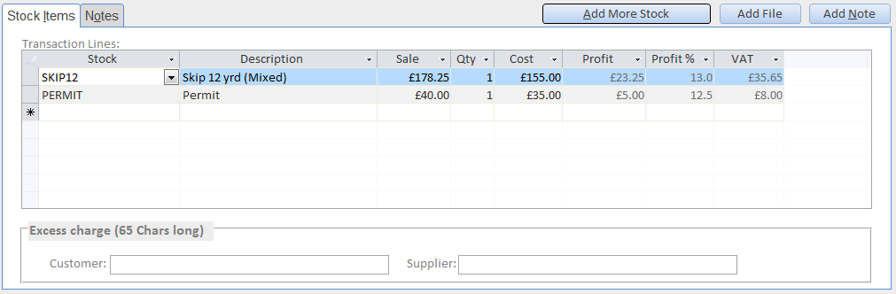
Additional items can be added manually or using the [Add Stock and Supplier] Button.
The Excess Charge text “Inc. xt - £x + p/t thereafter“ can be set using the [Add Text] button, and then edited.

Deleting Existing Lines
To delete a line in any grid, within the system, simply click:
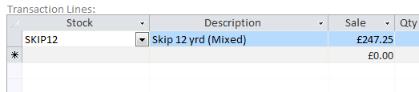
Click here to select line, and then press [Delete]

Supplier Contacts
After selecting the supplier, we see:
Google directions between Customer and Supplier
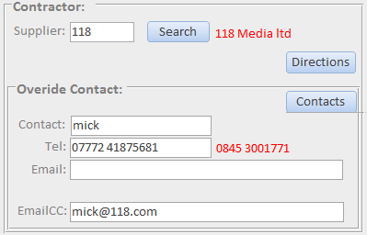
If edited a [Save] button will appear to save changes against the supplier
Additional Supplier Contact
Retrieve saved Supplier contacts

Special Instructions
Special Instructions appear on the Supplier e-mail and POR. These are entered in the large text box:
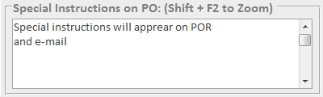

Credit Card
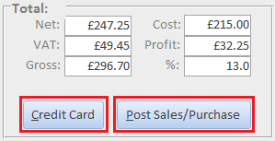
The [Credit Card] button opens a window to take the credit card order by SagePay.
The [Option] button has an option to override the need to take a credit card payment, which is sometimes used for obscure reasons.
All transactions are logged in notes.

Our order when finished looks like this:
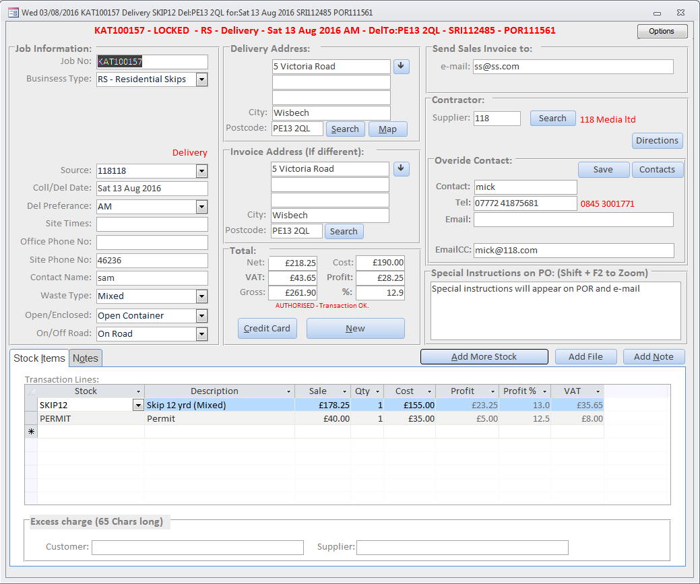
So we can see we need to now take the [Credit Card] payment…
Following that the [Post Sales/Purchase] button will be highlighted.

Posting the Delivery Order + Wait and Load
Pressing [Post Sales/Purchase] button will do the following depending on the business type selected:
Residential
- Any Pending Alarms are deleted
- SRI (Invoice with payment) is posted in Exchequer and e-mailed to customer after credit card reconciliation following day, using new button in Purchase daybook
- POR (Purchase Order) is posted in Exchequer and e-mailed to supplier for action
- POR is added to conformation List to double check with supplier that they are processing the order
- Comment is asked for (Alarm can be set, with defaults set on stock record).
- Order is taken off Work List if already on it
Commercial No Account
Same as Residential, but also captures “Cust Ref” input
Account
- Any Pending Alarms are deleted
- SIN (Invoice) is posted in Exchequer and e-mailed to customer for future payment
- POR (Purchase Order) is posted in Exchequer and e-mailed to supplier for action
- POR is added to conformation List to double check with supplier that they are processing the order
- Comment is asked for (Alarm can be set, with defaults set on stock record).
- Order is taken off Work List if already on it
After posting the [Post Sales/Purchase] button, becomes a [New] button, which allows Exchange, Collection and Excess.

Posting Exchange
Open existing Delivery/Exchange/Collection and press [New] on order to start new transaction, then select [Exchange] type.
Residential + Commercial No Account
- Any Pending Alarms are deleted
- SRI (Invoice with payment) is posted in Exchequer and e-mailed to customer after credit card reconciliation following day
- POR (Purchase Order) is posted in Exchequer and e-mailed to supplier for action
- POR is added to conformation List to double check with supplier that they are processing the order
- Customer is sent a “Please review” e-mail 1 day later to capture feedback
- Comment is asked for (Alarm can be set, with defaults set on stock record).
- Order is taken off Work List if already on it
Account
- Any Pending Alarms are deleted
- SIN (Invoice) is posted in Exchequer and e-mailed to customer
- POR (Purchase Order) is posted in Exchequer and e-mailed to supplier for action
- POR is added to conformation List to double check with supplier that they are processing the order
- Customer is sent a “Please review” e-mail 1 day later to capture feedback
- Comment is asked for (Alarm can be set, with defaults set on stock record).
- Order is taken off Work List if already on it

Posting Collections
Open existing Delivery/Exchange/Collection and press [New] on order to start new transaction, then select [Collection] type.
- Any Pending Alarms are deleted
- POR (Purchase Order) is sent to supplier for action
- Need for Collection Date is taken off
- Customer is sent a “Please review” e-mail 1 day later to capture feedback
- Comment is asked for (Alarm can be set, with defaults set on stock record).
- Order is taken off Work List if already on it
The purchase order e-mail now has a job summary, special instructions, and google maps link:

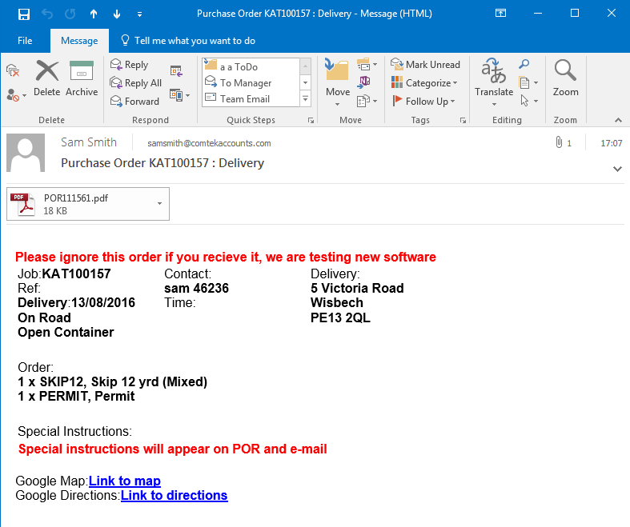

Posting Excess
Open existing Delivery/Exchange/Collection and press [New] on order to start new transaction, then select [Excess] type.
Residential + Commercial No Account
SRI (Invoice with payment) is posted in Exchequer and e-mailed to customer after credit card reconciliation following day
Account
SIN (Invoice) is posted in Exchequer and e-mailed to customer

Notes
Notes and Alarms can be viewed for the whole job from any Delivery/Collection/Exchange/Excess transaction:
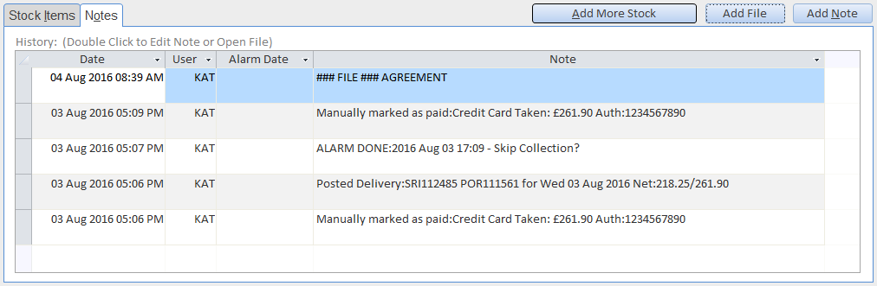
Double click to edit Notes/Alarms
Or open File if a file Link
Add Note/Alarm
Add Link to File

[Add Note] button adds a note, or an alarm.
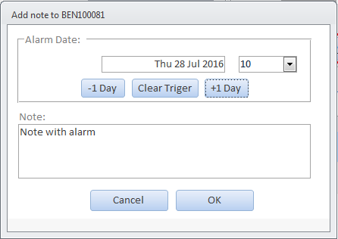
Note or Alarm text
Press twice for Alarm in two days
OPTIONAL: Alarm Date and Hour
OR Enter Day Number

Order Options Menu
This is at top right of transaction window
Mark Credit Card as Paid | By pass credit card validation
Unlock All fields | Unlock all locked fields – For use when control is required
Supplier View Record | Open the supplier record for currently selected supplier
Customer View Record | Open the Customer record for currently selected supplier
Supplier:e-mail Main Contact | Send e-mail to Supplier based on main contact
Supplier:e-mail Other contact | Send e-mail to Supplier based on additional contact
Delete Order | Deletes current unposted transaction Order
Open OLD Order Pad | Open an existing old order pad. Only visible if sheet exists

Other menus
Access from top of main menu. Only available to designated users.
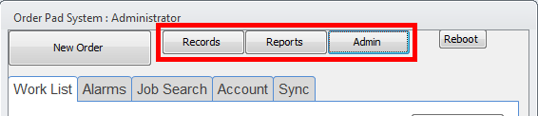

Records Menu
New Customer/Supplier | Add New Customer/Supplier
Stock Records | Edit Stock Records (See below)
Stock Group Records | Edit Stock Group Records (See below)
Re-Sync Exchequer Static Data | Does what it says
Email contents | Access the HTML used for e-mails.
Import Prices from Excel | Import Supplier from formatted spreadsheet

Reports Menu
Get Marketing e-mails | Get customer emails captured from x data
Supplier Ratings | View Supplier Ratings
Monthly Reports | Reports between two month ranges
Weekly Reports | Reports between two week ranges

Admin Menu
System Settings | Edit System Settings

Stock Records
Mirrors the Stock in Exchequer, with some extra fields:
Trigger Days  Trigger Description | If has a value then after posting a Delivery/Exchange then add an Alarm for possible collection, Permit etc…  X days in the future, with “Trigger Description”  If two, then will post the sooner of the two
Offer Price | Items which have a standard price.  OFF for items such as “Wasted Journey” and “Consumables”
AddWasteType | Put waste type in brackets when posting  30yrd Skip (Mixed)
Cost Centre | Cost Centre to allocate in Exchequer
Markup | Markup added to cost price when using suggested pricing
PriceContainer | Tick If Priced by Open/Closed Container  SKIPS *
PriceByWasteType | Tick If Priced by Waste Type  SKIPS *

- = if on then Price import must specify appropriate values

Stock Groups
Mirrors the Stock Groups in Exchequer, with some extra fields:
Supp Auth | If ticked, then Supplier must be specifically authorised to supplier any goods from this group.  Users will be warned if not authorised.
Order | Order in list when displayed, if the same number then alphabetic order

Importing Supplier Prices
A spreadsheet template is provided, to aid supplier price setup. This can list one supplier or multiples. Thus, many sheets could be consolidated, and importing on the required date. The [Reports] menu on the supplier record will list those suppliers which have or have not been updated.
The import spreadsheet should be opened and be the current active one. The import is activated from Menu [Records] >> “Import Price from Excel”. The layout of this is set in stone to some extent. The data is expected to begin at row 10 and have specific data in specific columns. Several columns are left blank; these can be used by user if need be. Any data imported will REPLACE existing prices against each supplier.
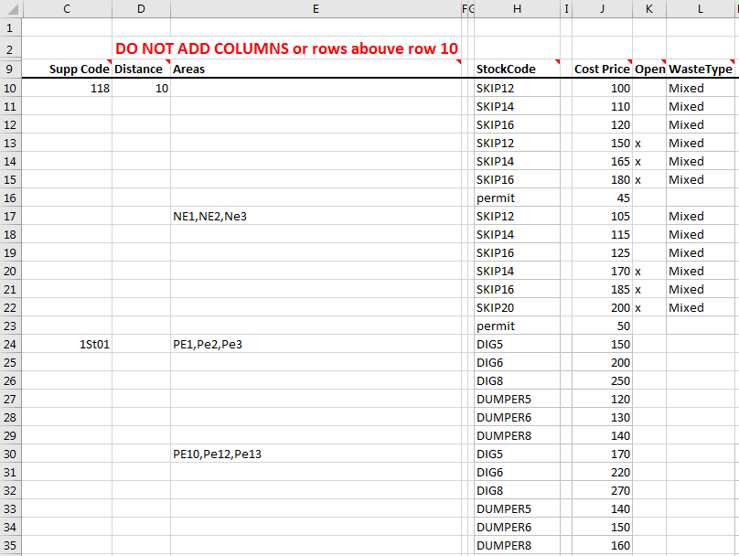
Explanation of rows in the example above:
Row | Description
10 | Set Supplier "118" for max distance of 10 Miles
11 | Supplier "118", distance 10, is remembered here, so import to “118”
12 | SKIP16 is £120 for enclosed, and Waste type “Mixed” for max distance 10 miles
15 | SKIP16 is £180 for Open (denoted by value in column K), and Waste type “Mixed” for max distance 10 miles
16 | Permit, waste type and Open/Enclosed is not applicable so is ignored
17 | Another Price band starts for Postcode Areas:NE1,NE2,NE3
19 | SKIP16 is £125 for enclosed, and Waste type Mixed for Postcode area NE1,NE21,NE3
21 | SKIP16 is £185 for OPEN, and Waste type Mixed for Postcode area NE1,NE21,NE3
23 | Permit, waste type and Open/Enclosed is not applicable so is ignored
24 | Update another supplier "1St01"
25 | DIG6 is £200 for Postcode Areas: PE1,Pe2,Pe3. Waster type and Open/Enclosed is not applicable
30 | Another set of prices for different postcode area

Install Notes
Each PC must have ODBC connection name: “AMAOrderPad”, with driver “SQL Server” 6.01….
Must be the following driver:
